Rowley Mile Racecourse Venue Access Information
Newmarket Racecourses are committed to ensuring that our venues are an easy and enjoyable experience for all to visit. To achieve this, we work towards addressing more than the minimum required by the Equalities Act (2010) and aim to ensure universal access.

Booking Information
Tickets are available to purchase online or by telephone on 0344 5793010. If you would like to check that the venue can meet your specific access requirements, please look at our access information or contact our customer relations team who will be able to provide you with further information.
If you have any queries, please contact our Customer Relations Department on 01638 675 500 (Option 4) or email newmarket.boxoffice@thejockeyclub.co.uk. Please note our office hours are Monday to Friday 9 am to 5.30 pm.

Personal Assistant Tickets
At Newmarket Racecourse, we are committed to providing all customers with the opportunity to enjoy a wonderful experience with each visit. As such, should you require a personal assistant in order to visit the racecourse, you are entitled to apply for one complimentary admission ticket for a nominated individual. The Personal Assistant ticket is only valid once you have purchased a ticket for yourself.
The personal assistant must be able to provide you with appropriate assistance which might include:
- Assisting you in moving around the racecourse
- Helping you evacuate the racecourse in the event of an emergency
- Accompanying and/or assisting you in using the racecourse’s toilets
- Assisting you in purchasing refreshments and food or using other services
- Assisting you in your transport to and from the racecourse

You will need to purchase your entry ticket and then immediately apply for your personal assistant ticket by sending your order number and supporting documentation via email to newmarket.boxoffice@thejockeyclub.co.uk
To avoid disappointment please be prompt when supplying your documentation as if an event sells out, we would not be able to offer a free personal assistant ticket.

Standard Race Days: As it is the Newmarket Racecourses policy that all persons under the age of 18 must be accompanied at all times when on course, the Personal Assistant Admission Policy does not apply to persons aged 17 and under on our standard race meetings as under 18’s are admitted free of charge when accompanied by a responsible adult aged 18 and above.

Newmarket Nights: For our Newmarket Nights events as all persons regardless of age must have paid for a full priced entry ticket, in this event we would offer a PA ticket for these events once we have proof of eligibility for under 18’s who require a Personal Assistant. Please note that any person(s) under the age of 18, cannot be classed as a Personal Assistant for health and safety reasons. As stated above, your personal assistant is to be able to look after you around the course, and to assist you with purchasing food and drink, where person(s) under 18 would not be eligible to purchase from our bars or our betting partners. They must be able to care for you in case of emergency and evacuation.

It is important to note that Newmarket Racecourses do not recommend Newmarket Nights as being suitable for children under 18, if you do wish to bring them as part of your party, it is at your discretion, they can attend as long as they hold a valid ticket to gain entry (and must be the same ticket as the adult has) and there is a responsible adult of 18+. By purchasing a ticket for an under 18 you are agreeing to these terms as well as our full terms and conditions. For further information on our Newmarket Nights please see our Music FAQ.
www.thejockeyclub.co.uk/newmarket/visitor-info/live-music-faqs/
Please note that tickets purchased through Third Party Ticket Agents and not directly with the Jockey Club will not be included in our PA policy and will not be offered a PA Free ticket.

Eligibility
The eligibility criteria for complimentary personal assistant admission are regularly reviewed and the racecourse reserves the right to update them from time to time.
Currently, those who receive one of the following benefits are eligible to apply for a free personal assistant ticket:
- Disability Living Allowance (DLA)
- Attendance Allowance (AA)
- Personal Independence Payment (PIP)
- Armed Forces Independence Payment (AFIP)
Additionally, people who are Registered Blind are also eligible.
Please note that, in all cases, the racecourse reserves the right to nevertheless decline to accept an application or to request additional supporting documentation if, in the racecourse’s view and discretion, there is reasonable doubt that the applicant would be at a substantial disadvantage in attending without a personal assistant given the accessible facilities and services available at the racecourse.

Required Supporting Documentation
When applying for your complimentary personal assistant ticket the following supporting documentation will be required in respect of one of the benefits referred to above:
- A copy of the current awarding letter from DWP or statement confirming receipt of the
- Allowance.
- A copy of the current awarding letter confirming receipt of the Personal Independence
- Payment.
- A copy of the current awarding letter confirming receipt of the Attendance Allowance.
- A specialist personal letter from the hospital to confirm that the person is in receipt of support services.
Please note that a Blue Badge is not accepted as evidence of eligibility.

How To Apply
Applications (including all proof) are to be made in writing to the racecourse via newmarket.boxoffice@thejockeyclub.co.uk in advance of the event.
Unfortunately, we are not able to offer complimentary entry for personal assistants on the day of the event. Please apply at the time of booking your ticket.
If you require entry to our Accessible Platforms to view the concert, please do confirm at the time of booking your personal assistant. These areas have limited capacity and must be booked in advance as these areas are very popular and do reach capacity. Should we not be able to accommodate your request and you would not be able to enjoy the event unless you were on the viewing areas, we would offer you a refund. Entry to the platforms is with wristbands only collected from our Free Pass Office, if you do not have a wristband, you would not be permitted access to the platforms.

Collecting Personal Assistance Tickets
Premier and Grandstand and Paddock and Garden Enclosure personal assistant tickets will be at the Free Pass Office. This is positioned at the Grandstand and Paddock entrance for the Rowley Mile. Please make sure you and your personal assistant are both present when collecting the personal assistant ticket.
Please note our Personal Assistant Policy does not apply to customers with temporary impairments such as broken bones, healing wounds and women who are pregnant.

Transport
The venue is situated outside the centre of Newmarket town and is accessible by all vehicle types with no restricted height access.
- Train: The nearest mainline train station is Newmarket situated 1.7 miles approx. from the Rowley Mile course.
- Outrider Coach Services: The Racecourse operates a subsided coach service travelling from the below location;
  - Cambridge train station
  - Royston train station (Car Park of platform 2)
  - Ely (Market Street)
  - Soham (High Street)
  - Bury St Edmunds bus station (Stand 9.)
The Ely, Soham, Royston and Bury St Edmunds service only runs on feature days. The coach stop for the Outrider Coach Services is more than 150m away from the entrances.
- Free Newmarket Shuttle Bus: There is a free shuttle bus service that operates from Newmarket train station and town centre to the racecourse at regular intervals. The drop off and collection point at the racecourse for this service is directly outside the Grandstand & Paddock Entrance. The bus services are run by an external company and if you require any specific information as to access on each service, please contact Neals Travel 01638 780066.
- Taxi: The taxi drop-off and pick up is situated outside the front of the Premier Entrance.

Car Parking
Designated blue badge parking is located within two main areas. These parking areas cannot be pre-booked. A blue badge must be clearly displayed to the parking marshal, and they will direct customers to the nearest available space.
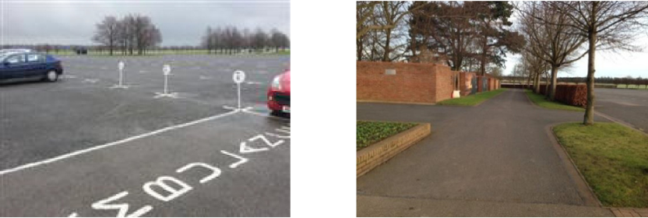
The blue badge holder parking bays for Annual badge holders/hospitality guests and Premier enclosure customers are situated at the front of the Annual Badge holders car park, directly outside Premier entrance. The car park is an open area of tarmac with loose chippings. The level ground to the entrance from the car park makes it accessible for wheelchair users without assistance. There are plenty of designated parking spaces directly in front of the Premier Enclosure entrance (28m). Each parking bay is approx. 560cm x 260cm. The patron does not have to cross a road and there are no height restrictions or barriers.

Blue Badge Parking Bays outside Premier Entrance & route to Premier Entrance from these parking bays.
Blue badge parking is also available outside the Grandstand & Paddock entrance. This parking area is for Grandstand & Paddock, Garden Enclosure customers. This parking area is situated to the rear of the venue, directly outside the Grandstand and Paddock entrance. The car park is an open area with mown grass surface; it is accessible to a wheelchair user although assistance may be required as there are areas of grass to manoeuvre. From this parking bay it is approximately 20m to the Grandstand & Paddock entrance and 150m to the Garden Enclosure entrance.
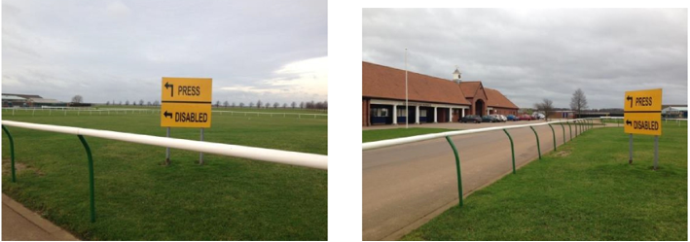

Signposted Blue Badge Parking area outside the Grandstand & Paddock entrance

Coach Parking
The coach park is located approximately 60m from the Grandstand & Paddock entrance. The ground surface is closely mown grass.

Golf Buggy
The Racecourse operates a golf buggy service in and around the Racecourse car parks to assist customers who require assistance in getting from their cars, coaches or taxi's to the entrances. To order this service, please make yourselves known to the car parking marshals who will arrange for the golf buggy to meet you at an agreed location. Please note, the golf buggy service has no facilities to transport wheelchairs or mobility scooters.
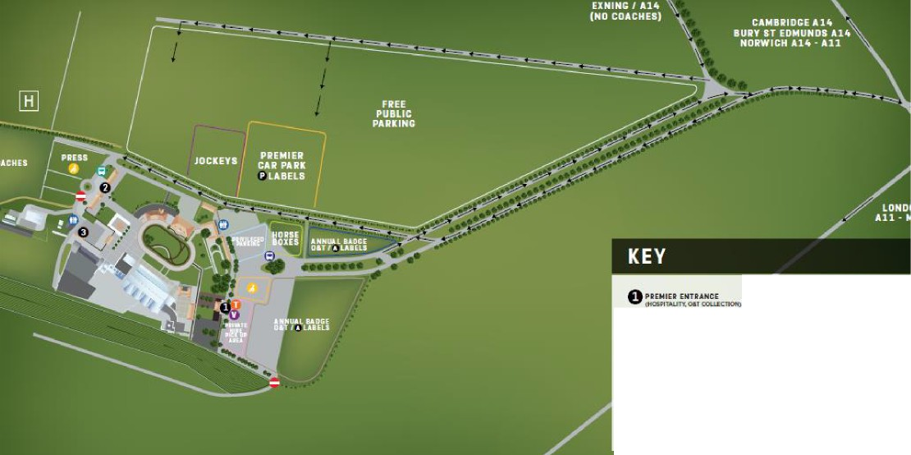
Car Parking Map at the Rowley Mile

Admission Entrances
Premier Entrance:
The Premier Enclosure entrance is positioned at the front of the Annual Badge Holders Car Park and is also the conference entrance on non-race days.
All access is on ground level with 3 double, outward opening doors of 160 cm. There is slight level change which consists of a small ramp which is permanent to each doorway. There is a member of staff stationed at this entrance on race days to provide assistance. The inside of the entrance building is vinyl & carpet.
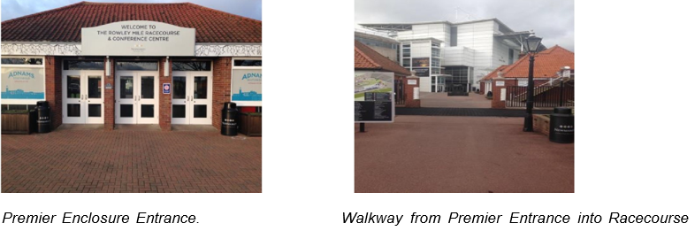
Customers with both Premier Enclosure and Grandstand and Paddock Enclosure tickets can access via the Premier Entrance. Grandstand and Paddock Enclosure customers will have to transverse an area of closely mown grass should they wish to use the Premier Entrance to access the Grandstand and Paddock Enclosure.

Admission Entrance
Grandstand & Paddock Entrance
The Grandstand & Paddock entrance is located at the far end of the venue, at the end of the racecourse drive.
All access is on level ground towards the entry gate. The gate is 100 cm wide with no level changes. The counter window is 102 cm from ground level. On race days there is a member of staff situated at the entrance to provide assistance.
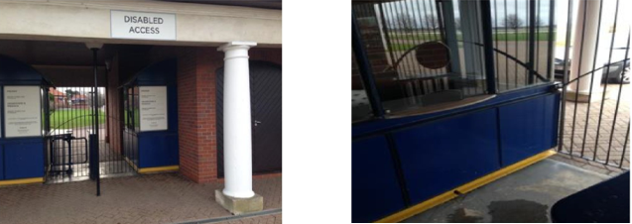

Grandstand & Paddock Enclosure Entrance

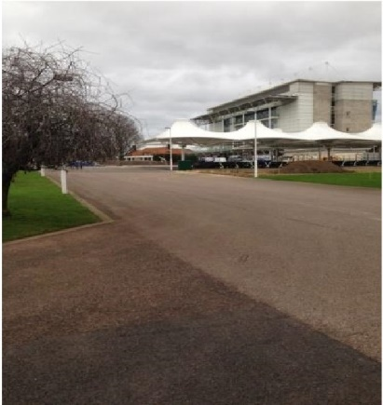
This entrance leads you to the Boulevard area incorporating the Information Desk, Food Court, Paddock, Hyperion Lawn and Millennium Grandstand. The area is tarmac with a medium incline toward the Grandstand area.

View from the Grandstand & Paddock Entrance looking towards the Boulevard Area, Hyperion Lawn on the left and the Millennium Grandstand.

Admission Entrance
Garden Enclosure Entrance
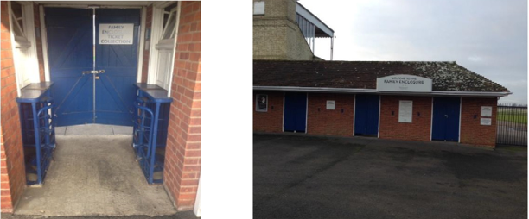
The Garden Enclosure Entrance is located 100m to the right of the Grandstand & Paddock entrance. The entrance is 103cm wide. The counter is 102 cm high and there is always a member of staff positioned here for assistance. The surface is tarmac with no level changes and the double doors are permanently held open. This enclosure is only open on selected racedays.

Premier Enclosure & Hospitality Areas
The Premier Enclosure is the top tier general admission ticket available for purchase. Premier Enclosure tickets holders can access all the facilities across the site including those in the Grandstand and Paddock Enclosure and the Garden Enclosure (excludes Hospitality areas).
Hospitality areas include the Champions Gallery on Level 3 of the Millennium Grandstand, which is a tiered panoramic restaurant which can be pre booked. Private boxes are located on the Level 4 of the Millennium Grandstand and Level 2 of the Head on Stand. All hospitality enquiries should be discussed with the Hospitality team on 01638 675 300 (Option 2).
The ground surface within the Premier Enclosure consisted of a mixture of paved areas and tarmac. The area trackside of the Grandstand in the Premier Enclosure is tarmac and is gently sloping towards the racetrack.
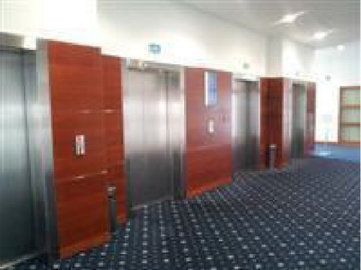
Access Lifts: There are 4 standard lifts located in the main foyer of the Millennium Grandstand, accessible either through the main ground floor hall or through the Hospitality entrance. The lifts are 10 metres from the entrance and the door width is 110cm. The dimensions of the lifts are 108cm x 40cm. The lifts have visual floor indicators and an audible announcer. The lift controls have tactile markings as well as Braille markings. There is no level change and the surface is carpeted. Access to the Premier Enclosure level 2 viewing area is via these lifts. These lifts also give access to the Champions Gallery Restaurant on Level 3 and the Level 4 Private Hospitality boxes.

Lifts in the ground floor foyer of the Millennium Grandstand leading to all floors

The Head On Stand is accessed via a standard lift located 5 metres from the entrance of the Head On Stand. This lift provides access to the Royal Box, Guineas Suite and Runners Lounge on the first floor of the Stand, and the Private Boxes and the Thoroughbred Lounge on the second floor.
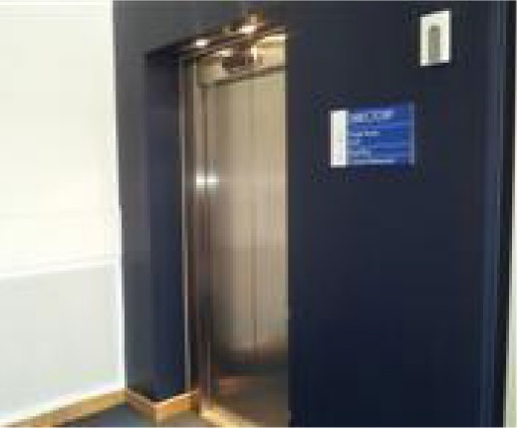
Please note that only wheelchairs less than 70cm can access the Runners and Thoroughbred Lounge, for further details please contact the Customer Relations team. The clear door width is 77cm and the dimensions of the lift are 100cm x 130cm. The lift does have a visual floor indicator and an audible announcer. The controls are at a convenient height for a wheelchair user and the controls are both tactile and Braille marked.

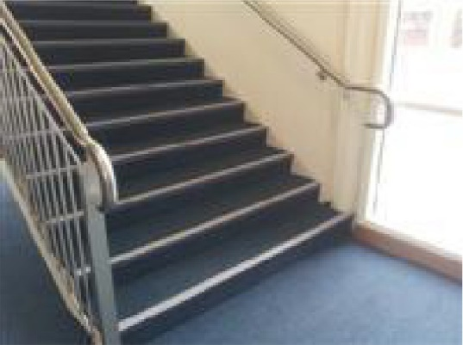
There are stairs located in the Millennium Grandstand and the Head On Stand which are options to use instead of a lift. There are approx. 15 steps between floors and the steps are clearly marked. There is a landing between staircases and the lighting levels are bright. Within the Head on Stand there is also a set of escalators operating to the second floor. These are one-way escalators and are manually controlled via staff. There are also a set of escalators on the outside of the Millennium Grandstand which give alternative access to Level 2 of the Grandstand (Trackside viewing, Millennium Bar & Severals Bar).

Accessible Toilets: All accessible toilets have clear signage near or on the appropriate doors. They are also highlighted on the site maps. In the case of any difficulty locating an accessible toilet please alert a member of staff.
All accessible toilets in public areas are fitted with a RADAR (bow shaped) key lock system. If you do not hold a RADAR key these may be obtained from the Information Point or Customer Relations Desk.
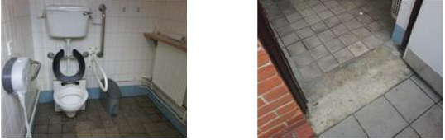
There is a unisex accessible toilet located in the courtyard near the Bistro Restaurant. The toilet is well signposted. There is a slight level change from paving to a tiled surface. The toilet has 4 handrails- all 70cm from the ground, an outward opening door of 88cm. The dimensions of the toilet are 160cm x 175cm. There is a lateral transfer space with a dropdown rail on the transfer side. There is no emergency alarm in this facility. The tap is of lever type and is a mixer tap.

Premier Courtyard Accessible Toilet (Unisex) Level change at the courtyard accessible toilet.
There is a unisex accessible toilet available in the Bistro Restaurant. The first doorway is 70 cm wide and is inward opening yet the cubicle door is 85cm wide. The cubicle is 215cm x 144cm. There are 4 handrails and a dropdown safety bar. There is no emergency alarm in this cubicle. There is a hand basin and a paper towel dispenser.
An accessible toilet is situated in the Autumn Double Bar (Ground floor of the Millennium Grandstand). There are also accessible toilets based on the 1st, 2nd, 3rd and 4th floors in the lift lobby areas. All the toilets are unisex. There are no level changes and the surface goes from carpet to tile. The doorways are 88cm and are outward opening. There are 4 handrails in each facility as well as dropdown safety bars. The toilets are 45cm from the ground and the hand basins are 75cm from the ground. The dimensions are 180cm x 195cm. There is lateral transfer space within each facility. There are emergency alarms within the cubicle.
There is an accessible toilet on the second floor of the Head On Stand (Private Boxes and Thoroughbred Lounge). The toilet is located at the end of the private box corridor, on the right-hand side as you enter from the lift lobby. The door is outward opening and is 85cm wide. The facility is unisex and there is plenty of transferable space with dimensions of 150cm x 104cm.
Viewing: There a number of viewing platforms available within the Premier Enclosure. The gradient of the ramps to access these platforms are no greater than 1:13.5. Chairs are available on request for personal assistants, but this is dependent upon space available on the platform.
There is an accessible viewing area located racecourse side of the Head On Stand. There is a permanent, 10 metre ramp with a moderate gradient and a level landing at the top of the ramp. The dimensions of the viewing area are 2m x Sm. There are 10 permanent seats located in the viewing area, 68cm from ground level. The view is good from a spectator point of view and is located very close to the winning line.
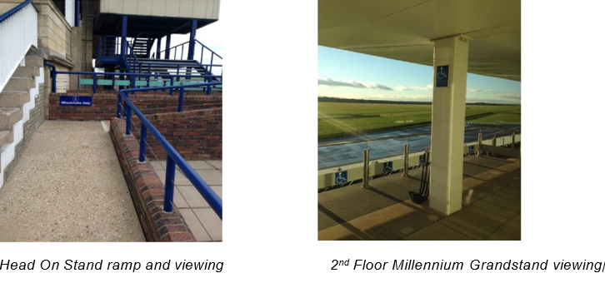

There is also an accessible viewing on level 2 of the Millennium Grandstand. This is access via the Millennium Bar and gives a very good view of the racecourse. Please be aware both these areas area can become heavily congested on feature racedays.
Bars, Restaurants, and Tote access: The Pravha bar, the Millennium Bar and the Autumn Double Bar are equipped with lowered trade counters or have exit access for traders to offer service from ground level. Whist not all Tote units have a lowered counter, all have an exit point to serve customers from ground level.
We apologise in advance that the Runners Lounge on the first floor of the Head on Stand and the Thoroughbred Lounge on the 2nd floor of the Head On Stand is only accessible via an escalator. Patrons requiring access to this facility must alert a member of the Racecourse staff.

Grandstand & Paddock Enclosure
The Grandstand & Paddock Enclosure includes the area all around the Pre-Parade, Parade Ring and Winners Enclosure.
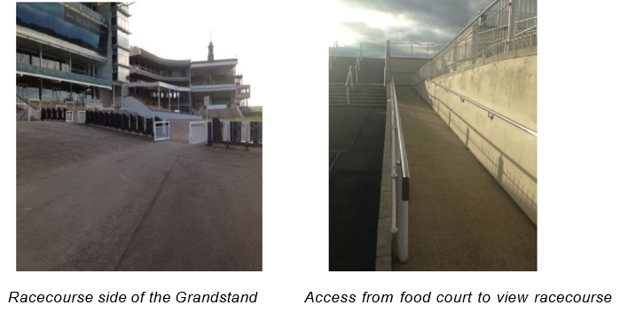
There are paved and tarmacked routes covering the venue within the Grandstand & Paddock enclosures. Racecourse side of the Grandstand is tarmacked with the area is sloping away towards the racecourse.

Information Point: The Information Point is located within the Boulevard area 60m inside the Grandstand and Paddock Entrance Turnstile. Ticket upgrades can be brought from here along with race cards. Lost property is reported here and RADAR keys can be obtained. There is a lower-level window for wheelchair users. On race days, there is a member of staff on hand to assist with all enquiries.
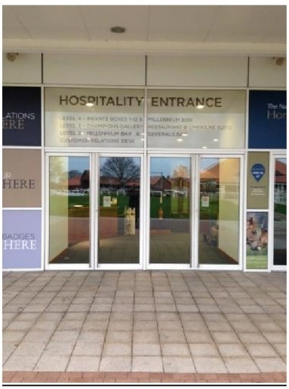
Customer Relations Desk (Hospitality Entrance): The Hospitality Entrance is located Paddock side of the Millennium Grandstand. There are 2 double inward and outward opening doors with a width of 178 cm. There is no level change however there is a metal threshold and the surface changes from paving to carpet. There is a member of staff positioned at the Customer Relations desk on race days and conference days to provide assistance.
Hospitality Entrance paddock side of the Millennium Grandstand
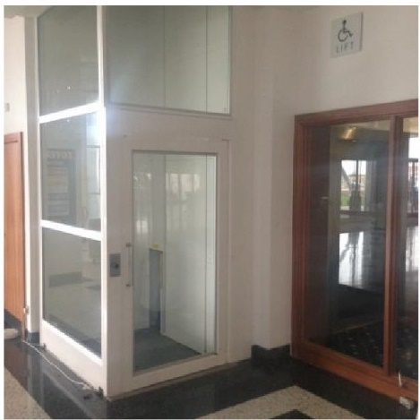
Access Lifts: There is a platform lift located in the main hall on the ground floor of the Millennium Grandstand. The lift is located 6m from the main entrance doors from the parade ring side and provides access to the first floor. The door width is 100 cm and the dimensions of the lift are 100cm x 150cm. The lift does not have a visual floor indicator or an audible announcer. The controls do not have tactile markings nor do they have Braille markings. The button inside the lift must be pressed and held down for the entire journey of the lift.

Accessible Toilets: All accessible toilets have clear signage near or on the appropriate doors. They are also highlighted on the site maps. In the case of any difficulty locating an accessible toilet please alert a member of staff.
All accessible toilets in public areas are fitted with a RADAR (bow shaped) key lock system. If you do not hold a RADAR key these may be obtained from the Information Point or Customer Relations Desk.
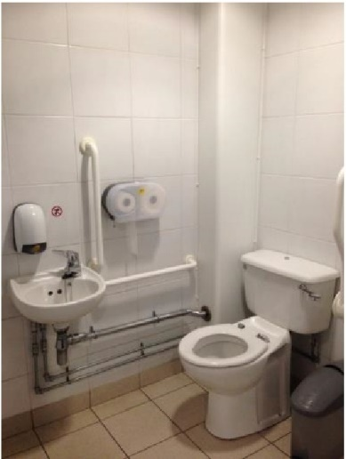
On the Ground floor of the Millennium Grandstand there is an accessible toilet in the main hall by the Betfred Betting Shop and the Gordon Richards Bar, there is also a toilet on level 1 of the Millennium Grandstand in the lift lobby. Both sets of toilets are unisex. There are no level changes and the surface goes from carpet to tile. The doorways are 88cm and are outward opening. There are 4 handrails in each facility as well as dropdown safety bars. The toilets are 45cm from the ground and the hand basins are 75cm from the ground. The dimensions are 180cm x 195cm. There is lateral transfer space within each facility. The facility on the ground floor is also a baby changing facility. There are emergency alarms within the cubicle.

There are clearly signed toilets located to the rear of the Frankel lounge as you enter from the Grandstand & Paddock entrance. The accessible toilets are located within the main toilets, with one designated accessible cubicle. Access is gained through two inward opening doors at a minimum of 88cm. There is a slight level change to each with a metal lip to negotiate. The cubicle doors are outward opening at a width of 91cm. There are 4 handrails in each with plenty of transfer space and a dropdown safety bar. The gent's toilet has dimensions of 145cm x 180cm and the ladies cubicle has dimensions of 163cm x 145cm. Both of the cubicles have an emergency alarm.
Viewing: There are a number of viewing platforms available. The gradient of the ramps to access these platforms are no greater than 1:13.5. Chairs are available on request for personal assistants, but this is dependent upon space available on the platform.
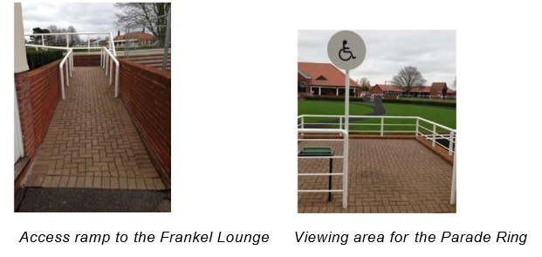
There are 2 ramps to view the parade ring, one is located directly opposite the Millennium Grandstand entrance and the other is by the Frankel Lounge. The Parade ring platform is a designated viewing area. The ramp is 15 metres, and the viewing area is large enough to incorporate wheelchair users. There are 4 permanently fixed seats, 68cm from ground level.
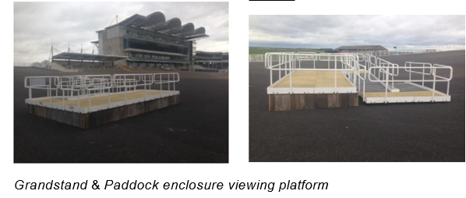
There is a specially designated viewing platform in the Grandstand & Paddock enclosure to view racing. There is a tarmac surface leading to the viewing area although there is a slight gradient to it. The viewing area is 5m x 2m and is railed all around for safety. The view of the racing is good - the racecourse itself is 5m in front of the platform.

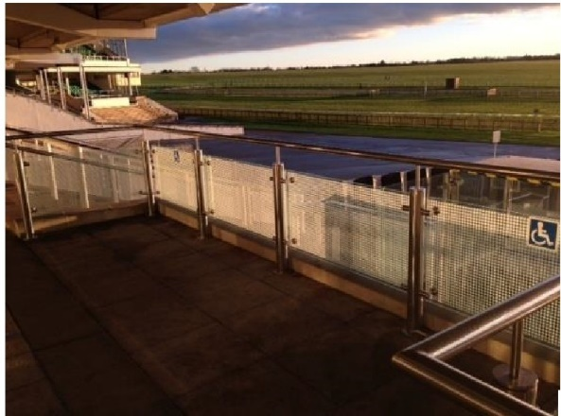
There is an accessible viewing area located on Level 1 of the Millennium Grandstand. This area is accessed via double doors from the carpeted bar area. Please be aware that this area can become heavily congested on feature days.

Level 1 Millennium Grandstand viewing area

Bars, restaurants, and Tote: All bars are equipped with lowered trade counters or have exit access for traders to offer service from ground level. Whist not all Tote units have a lowered counter, all have an exit point to serve customers from ground level.
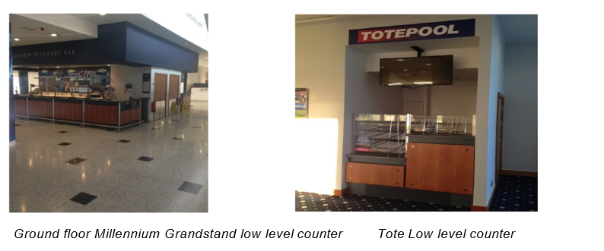
The Devil's Dyke Restaurant on the ground floor of the Grandstand is accessible to all on a level surface. The Frankel Lounge has a small door threshold on the door ledge, assistance is available on request. All the food court units are positioned on a flat tarmac surface within the Boulevard area.

Garden Enclosure
The Garden enclosure is an area for families to base themselves for a day's racing. Garden Enclosure ticket holders have no access to the Parade Ring area and have no access to a permanent building for shelter. Wet weather cover is provided via a marquee structure. Food, drink, garden furniture and gazebos can be brought into this area.
The area is made up of a primarily grassed area. In order to spectate any of the racing patrons must travel across grass.
Accessible Toilets: All accessible toilets have clear signage near or on the appropriate doors. They are also highlighted on the site maps. In the case of any difficulty locating an accessible toilet please alert a member of staff.
All accessible toilets in public areas are fitted with a RADAR (bow shaped) key lock system.
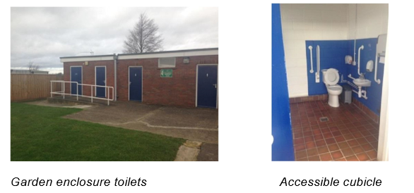
There are clearly signed and accessible facilities within the Garden Enclosure. The toilets are located to the right-hand side as you enter the Garden Enclosure. The toilet also has a baby change unit. There is a concrete, permanent ramp of 2 metres with an easy gradient. This is a unisex facility. The door opens outwards and is 96cm wide. There are 4 handrails and a drop-down safety bar. There is plenty of transfer space within the cubicle which has dimensions of 110cm x 135cm. There is an emergency alarm within this facility.

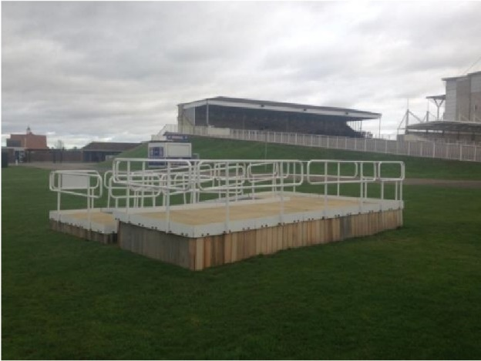
Viewing: The Garden enclosure viewing platform is 5m x 2m. Patrons must access this platform via a grass surface. The ramp is permanent and of a moderate gradient leading to a level area.

Bars, Restaurants, Tote: The Garden Enclosure is serviced via temporary bar units and food outlets. The Tote unit has an exit point to serve customers at ground level.

Assistance Dogs
Assistance dogs are welcome to attend with their owners without additional charge subject to production of a valid identity document from Assistance Dogs UK or an equivalent international organisation. A separate ticket is not required however owners should notify the racecourse in advance upon booking their event tickets so that any necessary arrangements can be made.
Assistance Dogs must be kept on leads at all times and we strongly encourage the use of an identifying harness to assist our teams in ensuring you are not challenged throughout the event.
You can use what3words to locate the dog park on the Rowley Mile spindles.trading.happily

Visually Impaired Customers
Printed materials such as bar menus are available upon request at all bars and all signage around the site is clear and in large print.

Involuntary Noise Issues
We welcome customers with involuntary noise issues or use noise to communicate rather than words. We are responsible for the enjoyment of the audience as a whole and therefore if disturbance is judged to be unreasonable for the nature of the event and prolonged, it may be necessary for us to ask you to take a break from largely populated areas. The venue does tend to be a lively and noisy area. Please speak to our Customer Relations Department if you require any additional services.

Personal Evacuation Plans
In the instance that a customer requires or would like to arrange a personal evacuation plan with the venues operations team, we would be very happy to help. Please contact our Customer Relations department who will relay the information onto the staff on the day. Please note that all are staff are trained and aware of the appropriate measures to undertake in case of an incident.

Additional Information
- Staff receive awareness and equality training.
- No alcohol is permitted trackside side of the Grandstand in the Premier Enclosure.
- No food and drink can be brought into the Premier Enclosure or Grandstand & Paddock Enclosures, if an exception is required, please call the contact number below.
- No garden furniture is to be brought into the Premier and Grandstand and Paddock Enclosures.
- Limited food, drink and garden furniture is allowed to be brought into the Garden Enclosure – please see our full picnic policy here: https://www.thejockeyclub.co.uk/newmarket/plan-your-day/food-drink/picnics/
Contact Information
Email: newmarket.boxoffice@thejockeyclub.co.uk Telephone: 01638 675 500 Option 4

